**Textual Analysis**

Simply Contracts have commissioned you to design and develop a simplified payroll system for their organisation. The company is based offshore on Shell Bay Island where each employee has to pay a standard rate of income tax on all of their earnings. The current tax rate is 20% but this can be changed by the government of the island. Employees can choose to be part of the company pension scheme where they pay 10% of their gross earnings to the scheme.

The company employ a mixture of full time and hourly paid workers. Full time employees are paid on a monthly basis where their pay is calculated as 1/12 of their annual salary. Hourly paid workers are effectively on zero hour contracts and are paid every Friday based on the number of hours they worked the previous week and their current hourly rate of pay. Any hours above 40 are paid at double their hourly rate.

The new system must have the ability for HR staff to add and edit employees and must store their name, address, phone number and a unique employee number. An employee can choose to join the pension scheme at any time. The salary for full time staff can be updated at any time, as can the rate of pay for hourly paid workers.

The contract manager enters the hours worked in the previous week for each hourly paid worker into a file every Monday. Every Friday the payroll staff run the weekly payroll system to produce the weekly payslips based on the hours worked in the previous week and the current rate of pay for each employee. On the last Friday in every month, the monthly payroll system is run to produce the monthly payslips based on the current salary of each full time employee.

The Shell Bay Island government require that all pay details are stored for at least one year. Simply Contracts only want to store paper versions of the payslips and hence there is no requirement to store the electronic payslips long term.

**NLA**

|  |  |  |  |
| --- | --- | --- | --- |
| **Name** | **Accept or reject** | **Reason** | **Class** |
| **System** | **Reject** |  |  |
| **organisation** | **Reject** |  |  |
| **Company** | **Reject** |  |  |
| **Shell bay** | **Reject** |  |  |
| **Island** | **Reject** |  |  |
| **pay** | **Reject** |  |  |
| **Standard rate** | **Reject** |  |  |
| **Income tax** | **Accept** |  | **tax** |
| **Earnings** | **Reject** |  |  |
| **Current tax rate** | **Reject** |  |  |
| **Employee** | **Accept** |  | **Employee** |
| **Government** | **Reject** | **External to program** |  |
| **Company pension scheme** | **Accept** |  | **Pension Scheme** |
| **Pay 10%** | **Reject** |  |  |
| **Gross earnings** | **Reject** |  |  |
| **Full time** | **Accept** |  | **Monthly payslip** |
| **Hourly paid** | **Accept** |  | **Weekly payslip** |
| **Paid on a monthly basis** | **Reject** |  |  |
| **Calculated as 1/12** | **Reject** |  |  |
| **Annual salary** | **Reject** |  |  |
| **Zero hour contract** | **Reject** |  |  |
| **Paid every Friday** | **Reject** |  |  |
| **Number of hours** | **Reject** |  |  |
| **Previous week** | **Reject** |  |  |
| **Current hourly rate of pay** | **Reject** |  |  |
| **Paid at double** | **Reject** |  |  |
| **Add and edit employee** | **reject** |  |  |
| **Store name** | **Reject** |  |  |
| **Store address** | **Reject** |  |  |
| **Store phone number** | **Reject** |  |  |
| **Store UID** | **Reject** |  |  |
| **Join Pension Scheme** | **Reject** | **Will be part of tax class** |  |
| **Salary** | **Accept** |  | **Salary** |
| **Salary update** | **Reject** |  |  |
| **Enter hours worked** | **Reject** |  |  |
| **Run weekly payroll system** | **Reject** | **Will be part of weekly payslip** |  |
| **Produce weekly payslip** | **Reject** |  |  |
| **Monthly payroll system** | **Reject** | **Will be part of Monthly Payslip** |  |
| **Produce monthly payslip** | **Reject** |  |  |

**Functional and Non Functional Requirements**

**Functional Requirements**

Pay Tax

Join Pension

Monthly pay

Weekly pay

Pay double rate

Add employees

Edit employees

Store Personal information

Update salary

Update hours worked

Run payroll system

**Non Functional Requirements**

Tax rate %20

**Moscow**

**Must have**

Monthly pay

Weekly pay

Add employees

Edit employees

Store Personal information

Run payroll system

**Should have**

Pay Tax

Join Pension

Pay double rate

Update salary

Update hours worked

**Could have**

Tax Rate

**Wont have**

**N/a**

**CRC Cards**

|  |  |  |
| --- | --- | --- |
| Employee | |  |
| * Create a new Employee * Store name * Store address * Store phone number * Store contract type * Store UID |  | |

|  |  |  |
| --- | --- | --- |
| Salary | |  |
| * Enter hours worked * Update monthly salary * Update weekly salary * Create salary | * Employee * Monthly payslip * Weekly payslip | |

|  |  |  |
| --- | --- | --- |
| Monthly Payslip | |  |
| * run Monthly Payroll * 1/12 of annual salary * Deduct tax * Deduct pension * Double rate added if applicable * paid monthly * Produce payslip | * employee * Set tax * Pay tax * Pension scheme * View payslip | |

|  |  |  |
| --- | --- | --- |
| Weekly Payslip | |  |
| * Run Weekly Payroll * Take in hours worked * Times by current rate of pay * Deduct tax * Deduct pension * Double rate added if applicable * Pay every Friday * Produce payslip | * employee * Set tax * Pay tax * Pension scheme * View payslip | |

|  |  |  |
| --- | --- | --- |
| Tax | |  |
| * Sets tax * Update tax rate | * employee * Pension scheme * Weekly Payslip * Monthly payslip * salary | |

|  |  |  |
| --- | --- | --- |
| Pension Scheme | |  |
| * Deducts %10 of the salary * Adds it to the employees Pension | * Monthly Payslip * Weekly payslip * Employee * Salary | |

**Use Case Diagram**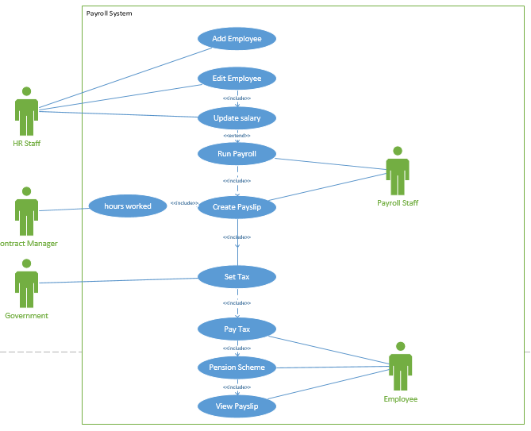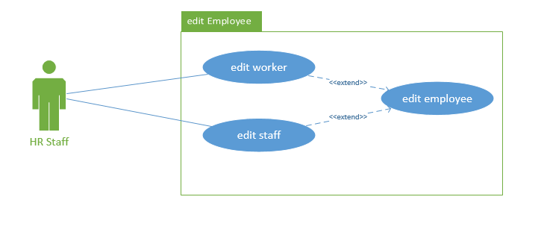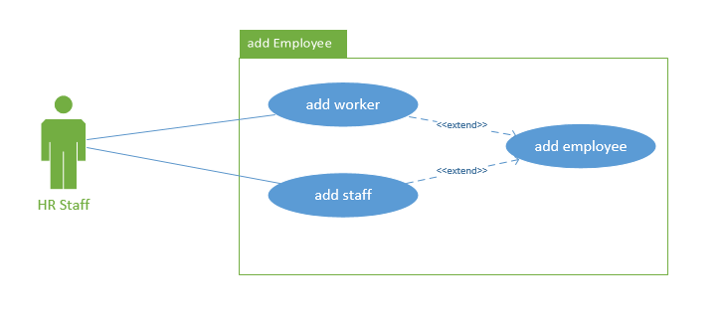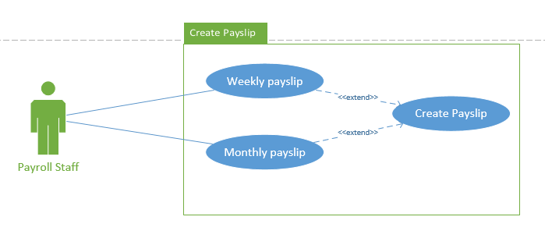

**Use Case Scenarios**

|  |
| --- |
| **Use Case: Edit Employee** |
| **Trigger event: user clicks on Employees** |
| **Pre Condition: Member of hr staff is signed in** |
| **Post Condition: Employee information is updated** |
| **Scenario: Normal Flow /Alternative Flow / Exceptional Flows** |
| **Normal Flow**   * HR Staff views the employees details * An employee is selected * Edit employee is clicked * Can change the employees name * Can change the employees address * Can change the employees phone number * Can change the employees name UID * Saves Edited information upon exiting * Shows message “employee information updated   **Alternative Flow**   * HR Staff clicks edit employee without selecting an employee * Returns an error message “please select an employee” |
| **Use Case: Create Payslip** |
| **Trigger event: HR Staff selects Create Payslip** |
| **Pre Condition: HR Staff member is logged in** |
| **Post Condition: payslip is created** |
| **Scenario: Normal Flow /Alternative Flow / Exceptional Flows** |
| **Normal Flow**   * HR staff views a list of employees * An employee is selected * The hours worked has already been entered by the manager * The HR staff has the option to change the contract type from weekly to monthly * The payslip is then created.   **Alternative Flow**   * The manager has not updated the hours worked. * An error message “The manager has not entered the hours worked yet” is shown |

|  |
| --- |
| **Use Case: add employee** |
| **Trigger event: create new employee is clicked** |
| **Pre Condition: HR staff must be logged in** |
| **Post Condition: New employee is created** |
| **Scenario: Normal Flow /Alternative Flow / Exceptional Flows** |
| **Normal Flow**   * The employees name is entered * The employees address is entered * The employees phone number is entered * The employees name UID is entered * The employees starting salary can also be entered at this stage * HR Staff clicks create * The new Employee is now Created * Message shown “Employee successfully added” * Employee is added to the database   **Alternative Flow**   * Not all fields have a value entered * An error message will show “please enter all fields” |

|  |
| --- |
| **Use Case: View Payslip** |
| **Trigger event: View Payslip is clicked** |
| **Pre Condition: The Employee must be logged in** |
| **Post Condition: Employee van view Payslip** |
| **Scenario: Normal Flow /Alternative Flow / Exceptional Flows** |
| **Normal Flow**   * The Employee enters their UID into the system * The System Brings up Their Payslip * Previous payslips can be viewed * The Payslip can be printed   **Alternative Flow**   * The Employee does not have their first payslip * An error message shows “you do not have any payslips at the moment, try again after your first pay” |